Ex.no:2 | EDA-Data Import and Export

Aim:

Algorithm:

Program:
# Import required libraries
import pandas as pd

# Load the Hotel Booking dataset
df = pd.read_csv("hotel_bookings.csv")

# Display the complete dataset
print("===== DATASET =====")
print(df)

# Display first five records
print("\n===== FIRST FIVE ROWS =====")
print(df.head())

# Display last five records
print("\n===== LAST FIVE ROWS =====")
print(df.tail())

# Display dataset information
print("\n===== DATASET INFORMATION =====")
print(df.info())

# Display statistical summary
print("\n===== STATISTICAL SUMMARY =====")
print(df.describe(include='all'))

# Display dataset shape
print("\nDataset Shape:", df.shape)

# Display column names
print("\nColumns:")
print(df.columns)

# Check missing values
print("\n===== MISSING VALUES =====")
print(df.isnull().sum())

# Export dataset to CSV
df.to_csv("hotel_bookings_export.csv", index=False)
print("CSV file exported successfully!")

# Export dataset to Excel
df.to_excel("hotel_bookings_export.xlsx", index=False)
print("Excel file exported successfully!")

import sqlite3

# Create SQLite database
conn = sqlite3.connect("hotel_booking.db")

# Export DataFrame to SQL table
df.to_sql(
"hotel_bookings",
conn,
if_exists="replace",
index=False
)
print("Dataset exported successfully to SQLite database!")
conn.close()

Output:
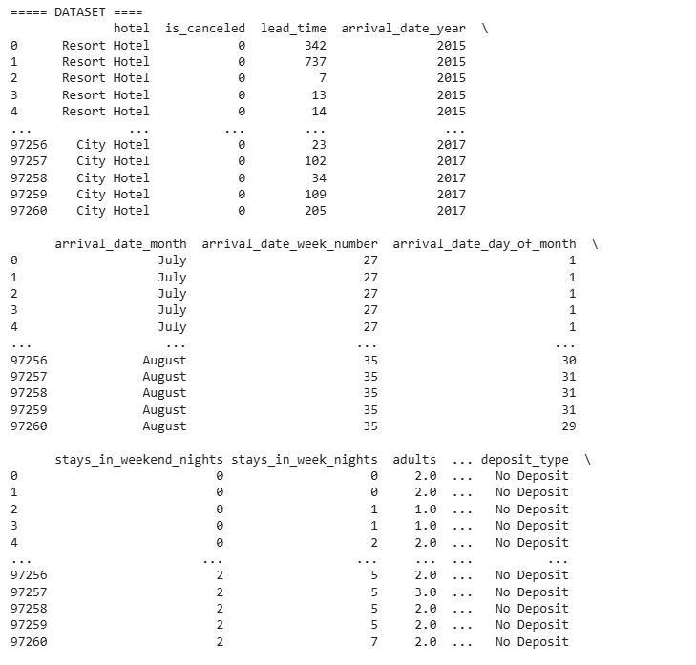
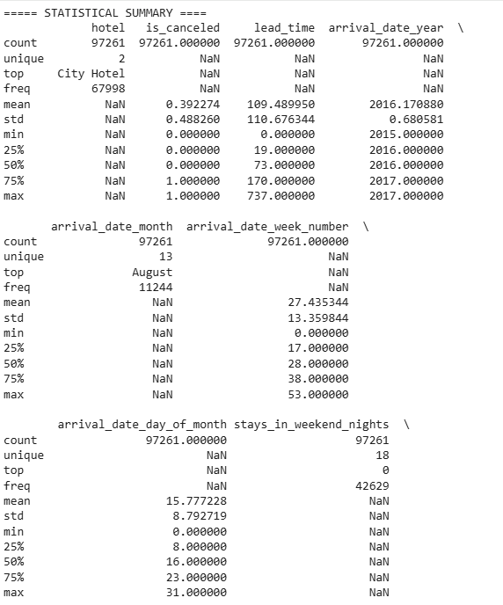
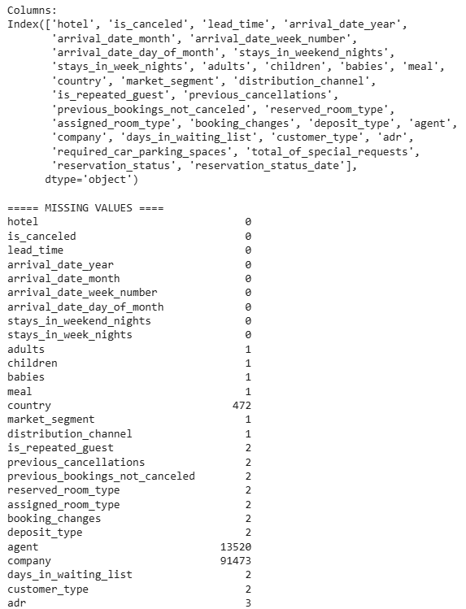

Result:

